**Transformational Investment Capacity (TIC)**

**Concept Note / Application Form**

***Please submit the completed form to*** [***TIC@msf.org***](mailto:TIC@msf.org)***.***

*For further information, visit:* [*msf-transformation.org*](http://msf-transformation.org/)*.***Top of Form**

|  |  |  |  |  |
| --- | --- | --- | --- | --- |
| TIC Idea Title: **Anti-Racism – Building Awareness and Changing Practices** | | | | |
| Date: November 23, 2020 | | Submitter Name: Joe Belliveau (on behalf of co-sponsoring entities listed below) | MSF Affiliation: MSF Canada | |
| Contact: | | [Joe.Belliveau@toronto.msf.org](mailto:Joe.Belliveau@toronto.msf.org) | Telephone: ­ | Skype: |
| Budget requested (Euros): 231K | | | Project Length (months/years): tBD | |
| Project Category:  HR/L&D  Operations/IT  Medical R&D  Efficiency Gains  Other (describe) | | | | |
| Project Type: | Incubator (< €250,000)  Large-Scale (€250,000 – €2.5M)  Very-Large-Scale (€2.5M+) | | | |
| *Sponsoring Sections:[1]* | CAMINO (Loic Jaeger), MSF East Africa (Teresa Bonyo), WaCA (Chibu Okonta), OCBA (Marta Cañas), MSF Southern Africa (Andrew Mews); MSF SARA (Farhat Mantoo); MSF Canada (Joe Belliveau)[2] | | | |

**Problem Statement / Need** (clearly articulate the challenge/issue to be addressed)

**Structural Racism at MSF**

Addressing structural racism has been identified as a priority for MSF, highlighted over the years in La Mancha, the People, People, People document, the People Respect and Value Rome/Dakar workshop, the IB Call for Change and more recently, with movement-wide discussions on Black Lives Matter protests (June/July 2020). To date, over 1,000 people signed the Open Letter, 190 comments were made on the Open Letter, numerous entries in Souk, Fluicity and MSF Facebook sites (social media tools), and the ExCom, International Board, 5 OCs and several other MSF entities have issued formal responses.

Furthermore, research supports that racism is a social determinant of health leading to health inequities. Addressing racism will therefore positively impact MSF’s social mission.[3]

**Lack of evidence-based understanding of structural racism**

According to the various exchanges, discussions, social media posts – to name a few- on various platforms across the movement, there appears to be a widespread lack of evidence-based knowledge and understanding of racism - that is an understanding anchored in the theories of anti-racism and/or informed by personal lived experiences. There also appears to be internal misalignment in the organizational on what racism is, and how it manifests in MSF. Although some sections have started their anti-racism journey, several entities across MSF have recognized a gap in being able to hold conversations on racism. This certainly inhibits the prospect of acquiring an understanding of racism that goes deeper than surface-level and ignites change. Furthermore, that self-assessed inability to discuss racism in multiple entities of the organization also jeopardizes the prospect of cross-sectional (i.e. involving multiple sections and entities of MSF) efforts to address racism.

Holding critical and productive conversations on racism can be challenging and uncomfortable. Very often, the discomfort comes from an incomplete understanding of what racism is, as well as from internalized narratives about the alleged invalidity of racism as a discussion point in given settings (i.e. geographical, social or organizational settings).

Many at MSF have expressed an interest in confronting this discomfort and in learning, both of which should result in action. Indeed, for any successful anti-racism strategy to be implemented, a solid understanding of racism as a system and its different manifestations, is critical. Furthermore, it is essential to not dwell in circular arguments but instead move from conversations to action in a way that is consistent with relevant social justice research and best practices available from the field of anti-racism.

To date no resources built on information and findings specifically from the field of anti-racism have been made systematically available to MSF staff and association members across the organization to provide some guidance to create a change in practices.   
Therefore, there is a lack of cross-sectional, evidence-based guidance to embed anti-racist praxis in MSF.   
Finally, some staff and association members of MSF have self-identified as willing to be part of that anti-racist change, but lacking the conceptual knowledge, language or skills: **the conscious unskilled**.  
Focusing on that population – the conscious unskilled-, can create room to: 1. facilitate an entry into an anti-racism journey in a productive and safe manner that is rooted in anti-racist literature and strategies, and 2. coordinate cross-sectional anti-racist practices in MSF that can lead to actions.

**Lack of conducive conversation mechanism and space**

To implement change, discussing and analyzing a given issue and its pertaining various manifestations is critical. This applies also when discussing anti-racism: for any long-lasting change to take place and become embedded in practices, it is critical that constant productive discussions take place to identify, analyze and rectify issues related to racism in MSF.  
Discussions at MSF are often anchored in a debate paradigm, which can be ill-fated and inappropriate when discussing racism. The format of debates is often intended to have one side show that their idea is better, and eventually the ‘better’ idea is intended to replace the other party’s idea. When framed in this way, debates include elements of supremacy and colonialism, and can promote polarization.  
This partially explains the frustration, even harm experienced by MSF staff who have wanted to have a conversation about racism at MSF in the hope of propelling practical anti-racism steps, but were confined to ill-defined and potentially counter-productive or unsafe forums and formats to enter the discussion.  
 In some cases, staff have attempted to apply MSF’s principle of “Speaking Out / Témoignage”, which, just like debates, is also part of MSF’s DNA. However, MSF’s Témoignage principle has been traditionally applied to events external to MSF and shared through one-way communication. While speaking out has its place and has most certainly catalyzed recent commitments to action across MSF, it does not directly facilitate the work to be done.   
If MSF is to truly address anti-racism, it will have to transform how discussions are framed to move from sterile debates to conversations that lead to long-lasting change.

Currently, MSF has neither a principle nor a framework suited for internal témoignage and reflexivity. Because the form and the function of anti-racism dialogue in MSF so far have been mismatched and not informed by any best practices or evidence from the field of anti-racism, the outcome has rarely been successful. The experience can, and in some cases has, become harmful and neither the understanding nor the organizational strategizing to address racism has advanced. Hence there is a disconnect between the commitment(s) to dismantle institutional racism in MSF and actual tangible change based on anti-racism practices. This reveals a need to find practical and measurable ways to increase evidence-based understanding of anti-racism, ensure collaboration to maximize the mobilization of this knowledge at the organizational level and translate said understanding into cross-sectional long-lasting actions.

**Proposal Description: Idea or Solution** (idea, business case, prototype, other)  
  
The project aims to develop some cross-sectional evidence-based guidance to embed anti-racism praxis in MSF.

Specifically, the project aims to:

* Design a journey with different entry-points into anti-racism awareness and practices
* Create a conversational framework to discuss racism
* Build/strengthen capacity to host conversations about racism

To reach the desired change, fostering an expertise-driven cross-sectional collaboration to embed anti-racism in MSF by mobilizing subject-matter experts, existing literature from the field of anti-racism and conscious unskilled actors in MSF, will be critical (see Table 1).

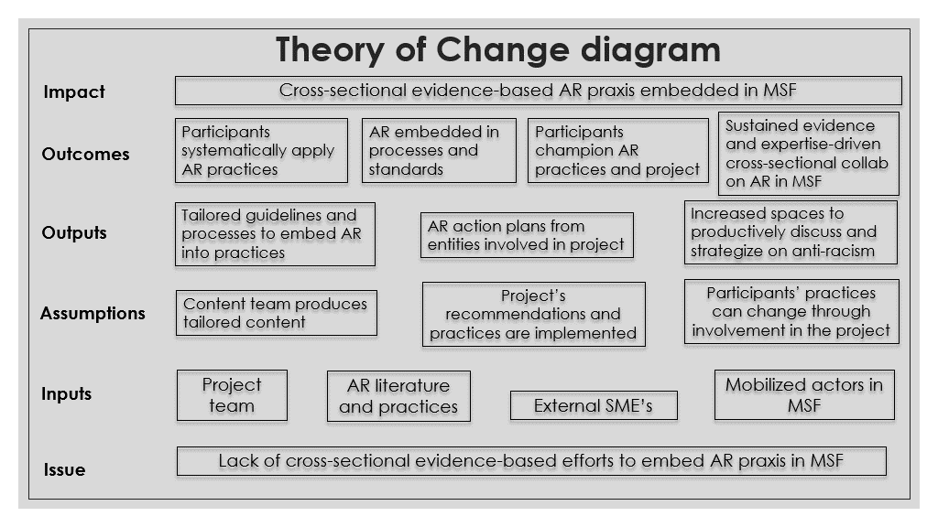

*Notes: The expected impact of ‘Anti-racism praxis embedded in MSF’ refers to MSF practices integrating anti-racism considerations. This consequently implies having the principle of anti-racism embedded into day-to-day actions in MSF.*   
*All expected outputs require actions to be implemented and sustained. The anticipated outputs aim to integrate anti-racism into the participating entity’s activities (e.g. outreach), practices (e.g. fundraising), processes (e.g. recruitment), guidelines (e.g. communications guidelines) and conversations.*   
  
Table 1: Theory of Change diagram

**Component 1: Facilitate an anti-racism journey to increase anti-racism awareness and change practices**  
  
The word ‘journey’ is deliberately used to speak to the fact that anti-racism is a constant process and not a destination. It is dynamic and multi-dimensional. Since racism is a complex system, it manifests in multiple ways depending on specific settings and contexts. As such, the mention of entry points below aims to acknowledge that there are several ways to get started in anti-racism praxis in the context of MSF.

* Provide a journey with multiple entry points into the topic of anti-racism that ties theoretical concepts (see table 2) to practical changes to implement (e.g. review of recruitment process, communications and advocacy efforts, training and performance assessment informed by anti-racism to name some examples of changes) Provide some context, references and explanations for each entry point to present why specific dynamics contribute to the system of racism.
* Offer some suggestions of next steps to prevent dynamics and practices that contribute to racism.
* Meet each individual, group, team where they are in their anti-racism understanding and practice.
* Provide users with tools and references curated by subject-matter experts (SME’s) and learning developers to practically apply a commitment to anti-racism.
* Tailor resources to increase understanding and change practices based on the specific sub-topic.   
  e.g. practical tips on how to talk about race and keep track of anti-racism maturity in a team, guidelines to write a job description that is informed by a commitment to anti-racism, coaching to identify and respond to micro-aggressions, etc.
* The journey is non-linear, non-prescriptive, although there are interdependencies between each place and those connections are made explicit.
* The process is discovery-based and is designed to increase anti-racism understanding and practices, as well as increase consciousness and understanding of fundamental concepts, perspectives and outlines (such as whiteness, privilege and colonialism), as premises of practices to be developed.

(see example in appendix 2)

|  |  |
| --- | --- |
| **Topic / Entry point** | **Sub-topics** |
| Race | What is race? An historical overview in western societies |
| The invention of race: scientific racism to justify European domination |
| Whiteness as a historical symbol of power and purity – and why it’s obsolete in the XXIe |
| Whiteness, privilege and moving away from White innocence |
| Race and the humanitarian sector | Humanitarianism and the colonial project |
| Colonialism, racism and the aid sector |
| Epistemological racism and the importance of centering on local knowledge |
| Everyday racism | Contextualizing racism |
| Unconscious bias |
| Tokenism and performative allyship |
| Racism in MSF practices | Racism in the aid sector imagery and narratives |
| Racism in hiring practices |
| Inequities in MSF international staff compensation |
| Becoming an anti-racist organization | Documenting the magnitude of racism in sections and projects |
| Creating a reporting system for cases of racism |
| Defining a response mechanism for racist acts in MSF |
| Liaise with existing anti-racism efforts in MSF |
| Create a conversational platform at different levels of MSF |
| Awareness campaigns |
| How to talk about racism today |
| Engaging in an anti-racism journey - best practices |

*This list will be constantly updated by the content team to reflect emerging needs in entities involved in the project.*  
  
Table 2: Anti-racism topics and sub-topics to be addressed by the project (February 2021)

Resources provided to understand the dynamics of racism will also discuss the coloniality of knowledge and practices, and consequently why seeking non-Western perspectives in MSF’s work ties into anti-racism efforts.

The project will **create strong links into related projects** such as People Respect and Value / Diversity, Equity and Inclusion (DEI), Global Induction, TEMBO (learning platform), the Core Excom’s shared action plan on (institutional) racism and discrimination, and other movement-wide initiatives on DEI. The project implementation in each MSF entity will see to ensure the involvement of all departments and units, including but not limited to Human Resources.

The resources to be included in each place will be mostly curated and selected from the vast number of existing resources, in multiple formats, produced by various groups, in different countries, in multiple languages.

Throughout the curation and selection process, gaps will be identified, and recommendations will be made for the production of MSF-specific resources. Some of the existing resources may simply need to be adapted or translated as opposed to re-created from scratch.

**Component 2. Conversation Space**

To address the gap in principles or frameworks for anti-racism discussions, we propose that the MSF debate framework be complemented -- if not transformed -- by a **conversation framework** that would include opportunities, spaces and trained conversation hosts.

Embarking on an anti-racism journey is challenging. It is recommended that such journeys, particularly in a large, global organization spread across many countries, be supported through a space where all aspects of the journey can be shared, discussed, and further enabled.

This space for conversation (virtual or physical) on racism will contrast with the traditional debate structure. A model such as the Art of Hosting, Art of Convening, Circle Way, Talking Circle will be adopted, and conversations will be moderated by trained hosts.

This type of conversation is aligned with the Way of Working at MSF that is being encouraged in many parts of the movement (e.g. OCP, Discussion-based Management approach, Discussion Spaces, OODA model for operational decision-making…)

**Component 3. Conversation Hosting – Capacity Building**

A decentralized approach to the MSF anti-racism journey will need multiple conversation spaces throughout the movement, anywhere, any time someone or a group sees fit to create one. To achieve this, this TIC project includes a training for conversation hosts and mediators, as well as a train-the-trainer session so that the organizational capacity will grow alongside the momentum of the project. Overtime, a large number of MSF staff across the organization will be well versed in this conversation approach.

**Articulation and integration of the project**

To maximize the odds of: a. reaching the target audience (i.e. conscious unskilled) and b. having newly acquired knowledge translate into practical changes, it is critical to ensure that the information curated by the content team is integrated into users’ work streams. This will increase the odds of embedding anti-racism efforts on a longer term.

For each MSF entity involved in testing and piloting content, efforts could be structured as follows:

|  |  |  |
| --- | --- | --- |
| **Steps** | **Description** | **Considerations to follow** |
| Identification of users | Focal points in a specific MSF setting (e.g. office, project, association) in charge of receiving, discussing and implementing curated content | -For practices to translate into changes, it might be interesting for users to be either involved in executing, overseeing or deciding day-to-day tasks  -Steering committee representatives could be involved in the identification of users in their respective MSF entity  -Users need to self-identify as willing to be actively part of the anti-racist change and involved in the implementation of anti-racist practices |
| Familiarization with TIC project | (Re)-introducing the project to identified users | -Clarifying the integration (i.e. how does the participation in the anti-racism TIC project fit with strategic priorities or ongoing projects in the entity?) is a priority to maximize the odds of efficiency  - The role of users in receiving, discussing and implementing curated content must be agreed upon and tailored to different contexts to ensure feasibility |
| Introduction of the conversational framework | Presenting and testing the methodology to discuss anti-racism practices with users. A ‘training of trainers’ for users to mobilize this methodology with other actors (e.g. team members) when implementing anti-racism practices, is also included in this phase | - To identify potential tensions and needs that might arise, topics selected to pilot the conversational framework could be topics that might be difficult to discuss in the users’ entity. Topics could be identified by users themselves with the guidance of the facilitator. |
| Introduction of curated content | Anti-racism content based on the ‘curriculum’ is shared with users on a regular basis via specific channels | - Communication channels and a communication strategy to be developed in each entity to ensure efficient transmission of information -Focal points to discuss the material shared with specific actors in their MSF entity |
| Elaboration and implementation of workplans | Workplans aim to implement anti-racism practices informed by curated content, as well as create ownership and accountability on anti-racism practices | -Workplans to be integrated with existing anti-racism efforts in the MSF entity (if any) |

*Please note that this structure is only a suggestion and is pending validation by the content team, Project Lead and steering committee.*

****

Overall, the approach will involve **strong collaboration** between the co-sponsors and the project team, particularly stakeholders that are based in predominantly non-White societies in Africa, Latin America and South Asia. The goal is not to create a western / “made in the north” product but rather to amplify voices of the MSFers who experience racism and identify strategies that any MSFer can follow to prevent racist dynamics in MSF.

**Description of Benefits** (what are the tangible benefits of this project to MSF patients, programs/operations, staff, etc.? what would success look like if this idea is scaled across MSF?)

Successful deployment of the project will increase evidence-based understanding of racism at MSF as well as anti-racism practice which will be tracked by the number of action plans developed by users and the extent to which they are implemented. Secondly, the model and approach of the content team might create a precedent and encourage cross-sectional collaboration driven by evidence to continue addressing racism in multiple MSF entities at the same time. Finally, by increasing the knowledge and understanding of those who are ready to take some steps on the journey (i.e. the conscious unskilled), the secondary benefit will be an indirect increase of awareness of racism and anti-racism practice with other segments of MSF (i.e the unconscious unskilled).

The primary tangible benefit for many MSFers who have recently become more aware of issues, is the ability and support to overcome the paralysis often associated with an emergent “consciousness” and receive guidance around what actions to take. Becoming more fully aware of racism at MSF can be overwhelming, unsettling, disruptive and challenging -- all emotions that can further cultivate avoidance, denial and the status quo. The project will see to identify resources and experts (internal and external) to make available emotional and psychosocial support.

Together the components of the project will address some elements of the Open Letter which calls for anti-racism action to be adopted across the movement. It would also be one of the visible, actionable early steps in demonstrating MSF’s responsiveness to this issue. Lessons learned would be shared with the network of MSFers who are dedicating their efforts to creating greater inclusion. This project is one step in the journey, which, together with related initiatives aims to create an inclusive, anti-racist MSF engaged in a decolonizing process.

**Alignment with Strategic Objectives** (link to MSF, OC and/or partner section objectives)

This project directly aligns with MSF’s priority to acknowledge and address structural racism in MSF. Commitments include statements from the Core ExCom, the International Board, all 5 OCs and many partner sections: *“Publicly acknowledge racism at MSF” (Open Letter); “Acknowledge institutional racism” (OCA); “Commit to deep, respectful reflection” (OCG), “Create safe spaces, listen, learn” (MSF UK); “Pursue DEI initiatives” (OCBA); “Each OC, partner session, branch office or field has to rethink how far are we reproducing a structural racism existing in our different countries and start to put in place ASAP mechanisms to change it” (MSF Brazil); “Embrace the conversation and the necessary change” (MSF Canada); “Commit to listening, learning, and taking action against racism.” (MSF USA);* *“Absolutely determined to ensure it disappears from our organization and will do anything we have to do to eradicate it” (OCBA). [add Core ExCom quote]*

**Phase 1 Workplan:** *TO BE DEVELOPED collaboratively with the Steering Committee and Subject Matter Experts once the project is approved*

|  |  |  |
| --- | --- | --- |
| **Stage** | **Timing** | **Deliverables/Activities** |
| **Discovery & Consultation Phase** | 3 months | * Release of general awareness content * Alignment on problem statement, approach to addressing the problem, and the expected outcome * Identification of main concepts and skills to include in the project * Development of Job Description/Terms of Reference for the Project Lead and other team positions   *General content development (including subsequent tailoring based on users’ needs and input from the content team) and testing with targeted end-users will be embedded in all phases* |
| **Recruitment of Project Team** | 3 months (concurrent with above) | * This can occur concurrently with the ‘Discovery and Consultation Phase’ (WaCA, MSF EAA and OCBA have indicated willingness to assist with recruitment) |
| **Design and Planning Phase** | 3 months (to start once the project lead is onboarded) | * Selection of tools and platform for conversation and web access to resources for journey * Design of overall approach, decision on each component * Selection of vendors, licensing as needed |
| **Development & Production Phase** | 5 months (Concurrent with the Consultation and Recruitment phases) | * Content creation, curation, assembly * Media assets production * Training of hosts |
| **Technical Testing and Deployment Phase** | 3 months | * Details to be determined based on design decisions |

**Project Team Overview** (who will develop the idea; if large-scale project, who is the team/Steering Committee)

**Steering Committee:** A Steering Committee will include members appointed by each co-sponsoring entity. Members are responsible for overall guidance of the project. They also provide input based on needs and requirements from their constituents, feedback on the concept and approach, and ensure effective internal communications within their entities and collectively toward the movement.

**Content Team** composed of ***Subject Matter Experts (SME’s)*** and ***Referents*** (internal and / or external).SME’s are appointed by each co-sponsoring entity; referents (internal or external) may be added to the team to support content development. The Content Team is responsible for guiding the development of a workplan and developing content for the different components of the project. SME’s are also responsible for engaging with constituents within their entities on the testing and development of the project.

**Project team:**

**Project Lead**: Responsible for project leadership, project management, deliverables, developing the project evaluation system, managing the project team, contracts and other resources, and managing relationships with the Steering Committee, the Content Team stakeholder and other stakeholders. Project Lead is also an SME.

**Mediation Consultant:** Assists in the design of the ‘conversational’ components of the project

**Organizational Development Consultant**: Design of approach to operationalize concept with an eye on culture transformation, change management, and learning. High level instructional design.

**eLearning Developer:** Instructional Design and eLearning production of online components

**Media Production Specialist:** Graphic and multi-media assets design and production

**Project Support**: Responsible for assisting the Lead in arranging stakeholder interviews, gathering relevant materials, conducting research, documenting findings, supporting workshops, and working sessions, etc.

*All team members will be well-versed in anti-racism concepts and practices.*

**Key Stakeholders:** (individuals, groups or organizations that may be impacted or may impact the project)

|  |  |
| --- | --- |
| Stakeholders | Deliverables/Activities |
| **MSF Staff** | * Primary target users for the learning materials * Select users will be solicited to provide input and feedback (Design Thinking) |
| **MSF Leadership** | * Secondary target for the learning materials – potential modules may target leadership |
| **MSF Association** | * Potential target for learning materials |
| **DEI Coordination Group** | * People responsible for DEI in each OC, Section and Region * Solicited to provide input and feedback |
| **DEI Initiative Leads** | * People responsible for DEI initiatives * Solicited to provide input and feedback |
| **HR Learning and Development** | * Involvement in input, feedback and formal dissemination for OCs, Partner Sections, Regions and Association |
| **TEMBO** | * Solicited to provide a learning platform and lessons learned on best practices |

**Equity, Diversity, and Inclusion Considerations** (does the project team reflect and harness MSF’s diversity? How will the project address barriers to meaningful inclusion and participation by equity-seeking groups[4]?)

The Steering Committee / Sponsor Group includes a majority perspective from regions whose populations are not predominantly of European descent and closer to MSF’s operations. User input and testing will also include a majority of MSFers from Africa, Latam and South-East Asia [TBD].

**Considerations in Scaling** (partnerships, intellectual property, contracts, other)

All materials developed will be available movement wide. Strong focus will be made on dissemination (particularly via TEMBO and the DEI Repository) and will include feedback loops. Translation into at least the 4 main languages of MSF – English, French, Spanish and Arabic] and ideally some widely-spoken local languages in countries of operation (e.g. Swahili, Lingala, Bengali, etc.).

**Cost Breakdown** (what will the investment funds be used for, budget, expected expenses)

**Budget based on 1 year in Euros: 231K**

**Budget details provided in annex**

Note: SME’s expected to give approximately 10-20% of their time to this project (this time is not budgeted by this TIC and it is expected that co-sponsoring entities absorb this cost within their budgets)

**Monitoring and Evaluation** (what are the outcome metrics and key performance indicators? how will you quantitatively measure impact?) ***to be finalized as part of Project Lead’s responsibilities***

**Adoption and uptake** – % deployment in target regions; modules used, # of trained hosts, # of conversation spaces facilitated; # of MSF staff engaged in an anti-racism journey and participating in hosted conversations; user-feedback through surveys on perceived increase in knowledge and change in practices.

**Impact** : % of participating entities that implement changes based on the project curriculum (e.g. changes in reporting system; updates to recruitment practices, career planning, onboarding, training, communication efforts, etc.)   
This metric can also be used as a proxy for 1. an increase in anti-racism awareness and 2. buy-in from relevant actors in co-sponsoring entities as those changes can’t be implemented without these 2 elements.   
  
Other impact indicators could include:   
- Increase in anti-racism awareness, ability to hold conversations on racism as reported by members of participating entities;   
- Springboard for the broader roadmap on structural racism and People, Respect and Value (measured by next actionable concrete actions taken up by other initiatives or by a Phase 2).

**Risk Analysis:**

|  |  |  |  |
| --- | --- | --- | --- |
| **Key Risks**  What would hinder project’s success? | **Risk Probability**  (H, M, L) | **Risk Impact**  (H, M, L) | **Risk Mitigation**  What actions would be taken to address the risks identified? |
| **Adoption / uptake is not achieved across the movement** | M | H | * Close collaboration with sponsors / Steering Committee members and the DEI coordination group (focal points across OCs, Partner Sections and Regions) to create buy-in and encourage adoption * Early connection with People Leaders to create buy-in and generate interest to use the resources * Connect with TEMBO and others in the movement who have created online resources to understand barriers to adoption (Inclusion of Persons with Disabilities, GDPR, etc.) |
| **Project competes with, overlaps with or fails to link with other related initiatives** | M | M | * Close collaboration and communication with: People Respect and Values TIC, the Core Excom Action Plan lead, the Repository, TEMBO and other DEI initiatives across the movement |
| **Resources not accessible for all MSFers** | M | M | * Materials created are simple enough for translation into local languages * Materials created are accessible on all devices (adaptive design) and with low bandwidth |
| **Some MSFers may deny there is an issue with racism** | M | M | * Focus on conscious unskilled (those willing and interested to learn more) * Socializing the project and the issues from the onset * Socialize MSF data evidencing racism in MSF (e.g. international HR indicators; testimonials; composition of leadership teams) |
| **Co-sponsor group or individual co-sponsors perceived as biased or inappropriate** | L | L | * Collaboration with entities from across the movement, incorporating regions whose populations are predominantly not of European descent * Socialize idea that the onus to understand and unpack racism does not lie with those who experience it. The project sponsorship is a reflection that, to decolonize MSF, sections in Europe, North America and Australia can use their power and privilege to serve as a catalyst to amplify voices |

**Dependencies / Linkages** (note if there is a link to other projects (TIC, MSF, external) or dependencies)

This project will have strong links into the People Respect and Value (DEI) TIC, TEMBO, the Core Excom’s shared Action Plan on (institutional) racism and discrimination, and other movement-wide initiatives on DEI

**Have you submitted your proposal to another MSF entity and did not obtain approval/funding? If yes, add details.**

No

**APPENDIX 1**

**BUDGET**

**APPENDIX 2**

EXAMPLES OF JOURNEY PLACES, WITH MULTIPLE ENTRY POINTS.

(as per Stanford model – for idea sampling purposes only – actual content not suggested or endorsed)

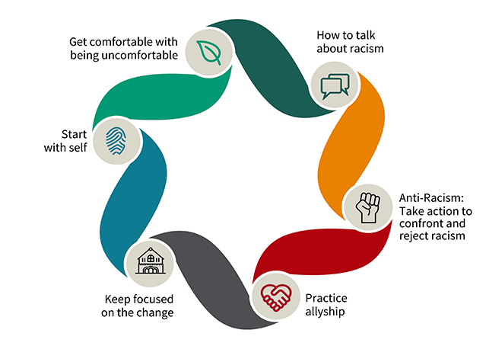

Each place on the journey is supported by several resources to explore What, Why, How of each place.

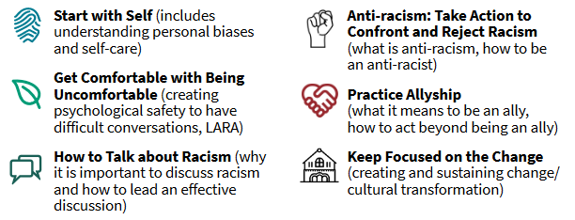

1. Proposal Sponsorship Form must be completed by sponsoring OD/Partner Section.
2. MSF Australia has also been approached and is considering possible co-sponsorship as of drafting this note
3. See [Gee and Ford, 2011](https://www.ncbi.nlm.nih.gov/pmc/articles/PMC4306458/); [Gee, 2016](https://healthequity.globalpolicysolutions.org/wp-content/uploads/2016/12/RacismasSDOH.pdf); [Williams, Lawrence, Davis, 2019](https://www.annualreviews.org/doi/10.1146/annurev-publhealth-040218-043750#_i15); [Wellesley Institute, 2012](https://nccdh.ca/resources/entry/colour-coded-health-care)
4. Women/girls; persons with disabilities; black, Indigenous and people of colour; members of the LGBTQ2S+ community, etc.